

A Mini Project Report

DEPARTMENT OF COMPUTER ENGINEERING
AND
APPLICATIONS

Presented by :- Under the Supervision of :-

Kunika Agrawal Mrs. Ruchi Talwar
Raj Jakhad
Sourabh Vanshkar

The project entitled, “Blood Unity”, is successfully accomplished by “Kunika Agrawal, Raj Jakhad , Sourabh Vanshkar” of V semester and is approved towards the partial fulfillment for the requirement of degree of Btech C.S.E.

Project Guide: MRS Ruchi Talwar Internal Examiner

Program Coordinator: Mr. Subhash Agarwal

ACKNOWLEDGEMENT

The whole process of developing the project has been quite an experience; a lot of new and interesting things helped me in making this Project a success.
We are highly indebted to Mrs. Ruchi Talwar for all the help they provided us throughout the project completion. He was closely involved during all stages of development, right from its inception implementation.
We wish to express our heartiest and venerable regards to our Program Coordinator: Mr. Subhash Agarwal .We are highly indebted to respected madam for all the support that he has always provided for getting all the information for project.
We are also expressing our gratitude to all the professor of GLA University for providing us valuable support and inspiration all through our Btech C.S.E course. We are also thankful to the library staff of our Institute for their help and for providing books and information to us regarding this project.
We express our profound gratitude to all friends who have made innumerable contribution affection and support for the completion of this project successfully and effectively.

CHAPTER-1

INTRODUCTION

  - Project Over View:-

The primary goal of the "Blood Unity" project is to promote and facilitate blood donation to ensure a steady and reliable supply of blood for medical emergencies, surgeries, and other healthcare needs. The project aims to unite communities, organizations, and individuals in a collective effort to save lives through voluntary blood donation. By combining awareness, community engagement, technology, and collaboration, the Blood Unity project seeks to create a sustainable and impactful initiative that positively influences the culture of blood donation.

1.2 Technology Over View :-

- HTML,CSS.
- JAVA Script.

About HTML and CSS importance:-

HTML is a programming language used to create a websites basic foundation.
CSS is a language used to set designs on stylesheet made through html.
Java script provides the functionality to the website build through html and css.

1.3 Organization Over View:-

Today is the era of information technology and everything is going to be computerized. Almost all institute, company and organization are using computer in their day to day activities. They combine their computers and form network so that they can share their resource and data. Many software companies are working to develop SOFTWARE APPLICATIONS for different organizations in almost every domain. For developing any software from scratch much of the effort, time and money are required.

To make standalone USER APPLICATION, you will probably need the following expertise:
- A computer interface designer
- A database programmer
- Experienced, knowledgeable script writer.
- And Knowledge of Technology.

Now the main issue involved here is how the efforts of these expertise’s can be saved. All organization needs their system to be automated these days therefore they give their projects to the software companies. We are going to develop an application for car dealers, because the manual approach used by the various car dealers is very cumbersome and required lots of paper work. So car dealer/show-rooms needs this type of system that will help them to improve their efficiency and overall results of the car show room. Also this approach is more customers friendly.

1.3.1 Process Model:-

In order to evaluate the quality of a design representation, we must establish technical criteria for good design. Later in this chapter, we discuss design quality criteria in some detail. For the time being, we present the following guidelines:

1. A design should exhibit an architectural structure that

(1) Has been created using recognizable design patterns.

(2) Is composed of components that exhibit good design characteristics.

(3) Can be implemented in an evolutionary fashion, thereby facilitating Implementation and testing .

2. A design should be modular; that is, the software should be logically Partitioned into elements that perform specific functions and sub functions .

3. A design should contain distinct representations of data, architecture, Interfaces and components (modules).

4. A design should lead to data structures that are appropriate for the objects to be implemented and are drawn from recognizable data patterns.

5. A design should lead to components that exhibit independent functional
characteristics.

6. A design should lead to interfaces that reduce the complexity of connections
between modules and with the external environment.

7. A design should be derived using a repeatable method that is driven by
information obtained during software requirements analysis.

CHAPTER-2
System Analysis

System analysis is a crucial phase in the development or improvement of a system. It involves a detailed study of a current system or a proposed system to identify problems and opportunities for improvement. The primary goal of system analysis is to understand and document how a system operates, what it is supposed to achieve, and how it can be enhanced to meet user needs more effectively. Here's an overview of the key aspects of system analysis:

Understanding the System:
Scope Definition: Clearly define the boundaries of the system under analysis. Identify what is included and excluded from the system.
Objectives Identification: Determine the goals and objectives of the system. Understand the purpose it serves and the problems it aims to solve.

Requirement Gathering:
Stakeholder Interviews: Conduct interviews with key stakeholders to understand their needs, expectations, and requirements.
Document Analysis: Review existing documentation, reports, and other materials related to the system.

Data Analysis:
Data Collection: Identify the data inputs, outputs, and processes within the system. Data Modeling: Create data flow diagrams, entity-relationship diagrams, or other models to represent the flow and structure of data within the system.

Time Feasibility:-
Our project has a length enough that can be completed in a given period of
Time. So our project fulfills the Time Feasibility Constraint.
As such we do not have any special hardware and software resource
Requirement and the human resource is competent enough to complete the
Project in a specific time .Thus the Resource Feasibility is also fulfilled.

Process Analysis:
Process Modeling: Develop process flowcharts or diagrams to represent the sequence of activities within the system.
Identify Bottlenecks: Identify any inefficiencies, bottlenecks, or areas where processes can be improved for better performance.

System Architecture:
Hardware and Software Analysis: Evaluate the current hardware and software components of the system.
System Interactions: Understand how different system components interact with each other.

Feasibility Study:
Economic Feasibility: Assess the economic viability of implementing changes or developing a new system.
Technical Feasibility: Evaluate the technical capabilities required to implement proposed changes.
Operational Feasibility: Determine if the proposed changes are feasible within the operational context of the organization.

Risk Analysis:
Identify Risks: Identify potential risks associated with system changes or development.
Risk Mitigation: Develop strategies to mitigate or manage identified risks

Requirement Specification:
Functional Requirements: Clearly define the functional requirements of the system, detailing what the system must do.
Non-functional Requirements: Specify non-functional requirements, such as performance, security, and usability criteria.

Documentation:
System Documentation: Create comprehensive documentation outlining the existing system, the proposed changes, and the requirements for the new system.
User Manuals: Develop user manuals and training materials to assist users in understanding the system.

Evaluation and Recommendations:
Evaluate Alternatives: Assess different options and recommend the most suitable solution.
Cost-Benefit Analysis: Provide a cost-benefit analysis for proposed changes.

Presentation and Approval:
Present Findings: Present the results of the system analysis to stakeholders.
Obtain Approval: Seek approval from relevant stakeholders for proposed changes or system development.

Data Flow Diagram:-

DONOR
Blood donation website
R

Context diagram
Blood unity
Request
Response

Fig3.1: Level 0 DFD

CHAPTER-3

Software Design

3.1 Design Objective And Continents:-

The waterfall process model used to divide tasks for developing software.
Analysis
Designing
Implementation
Documentation
Planning
Delivery Report
Table Structure:-

S. No. | Task Name | Start | Finish | Week’s  (Approx.)
1 | Analysis&Planning | 02/11/23 | 9/02/23 | 1
2 | Designing | 14/11/23 | 22/11/23 | 2
3 | Coding | 15/11/23 | 22/11/23 | 2
4 | Testing | 22/11/23 | 24/11/23 | 1
5 | Implementation | 25/11/23 | 25/11/23 | 1
6 | Documentation | 26/11/23 | 27/11/23 | 1
7 | Total | - | - | 8

  - Input & Output Design:-

3.5.1 Screen Layout:-

Register page:

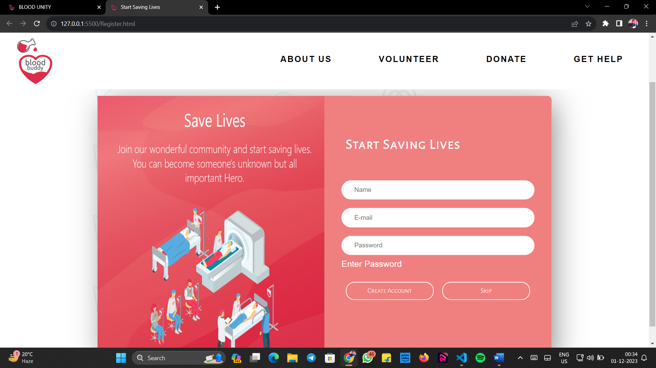

Main Window:

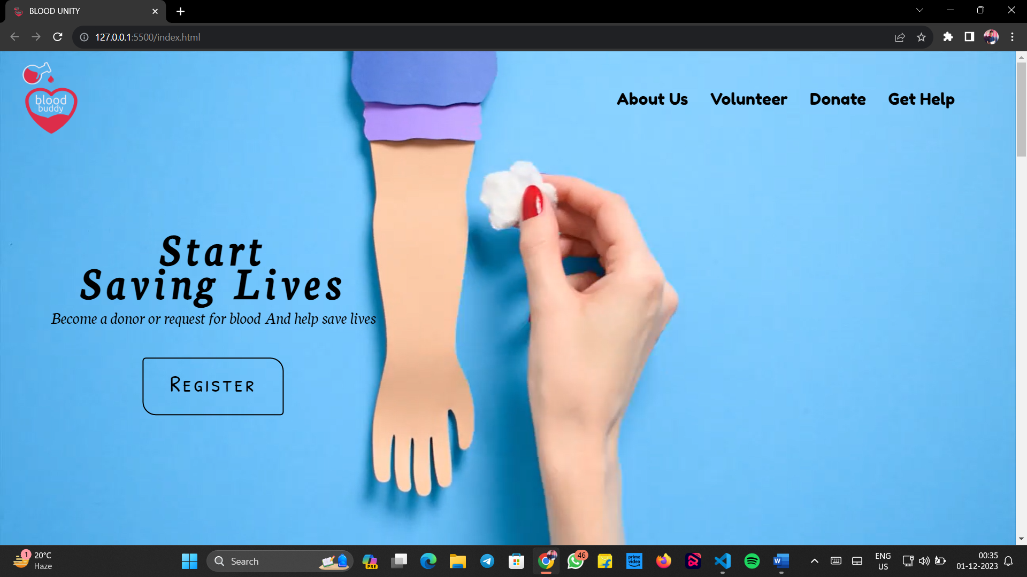

About Us :

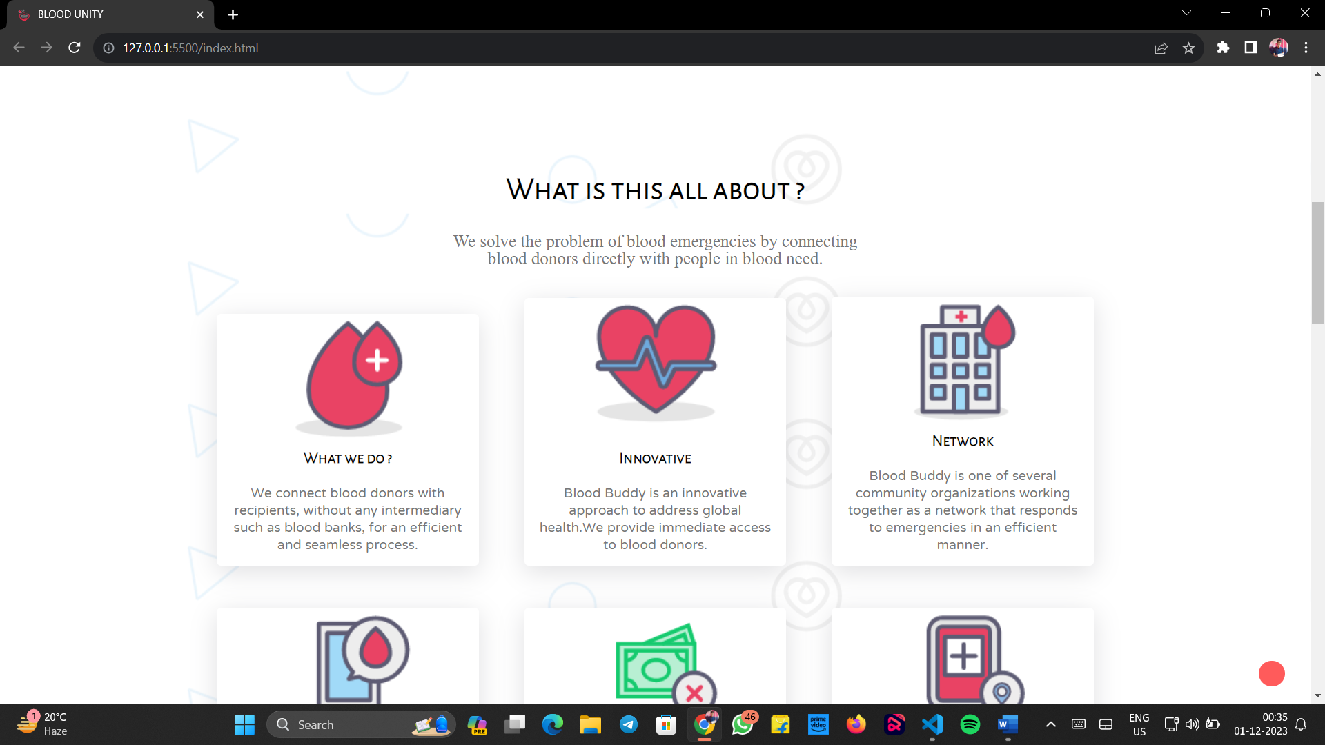

Volunteers Section :

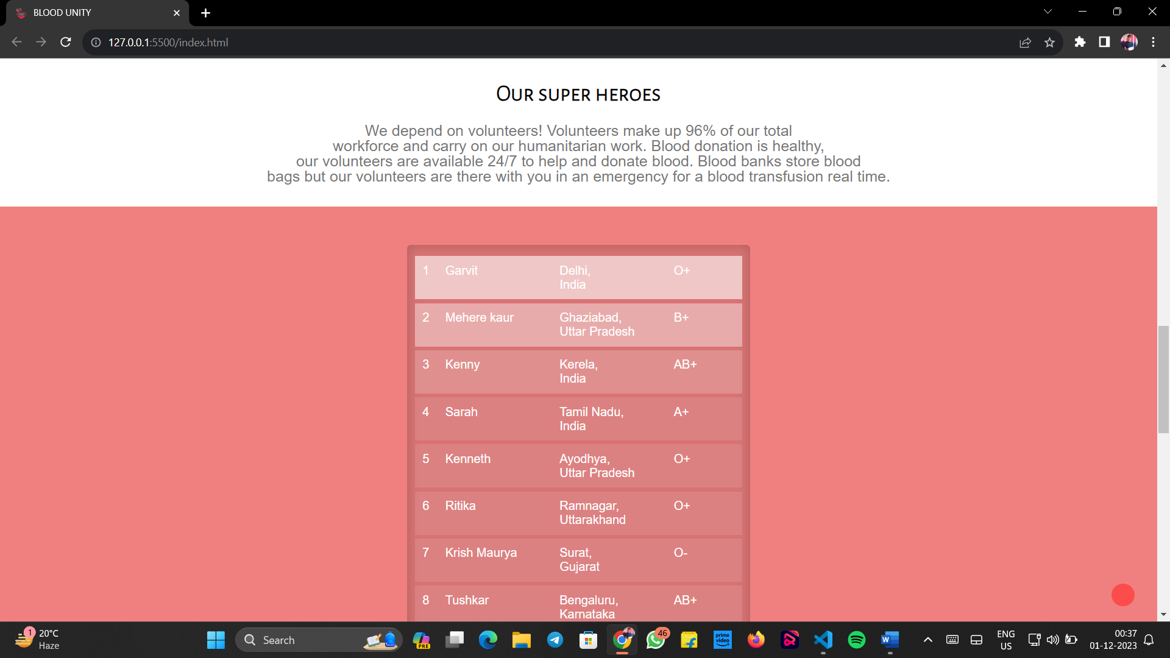

Get Help Section :

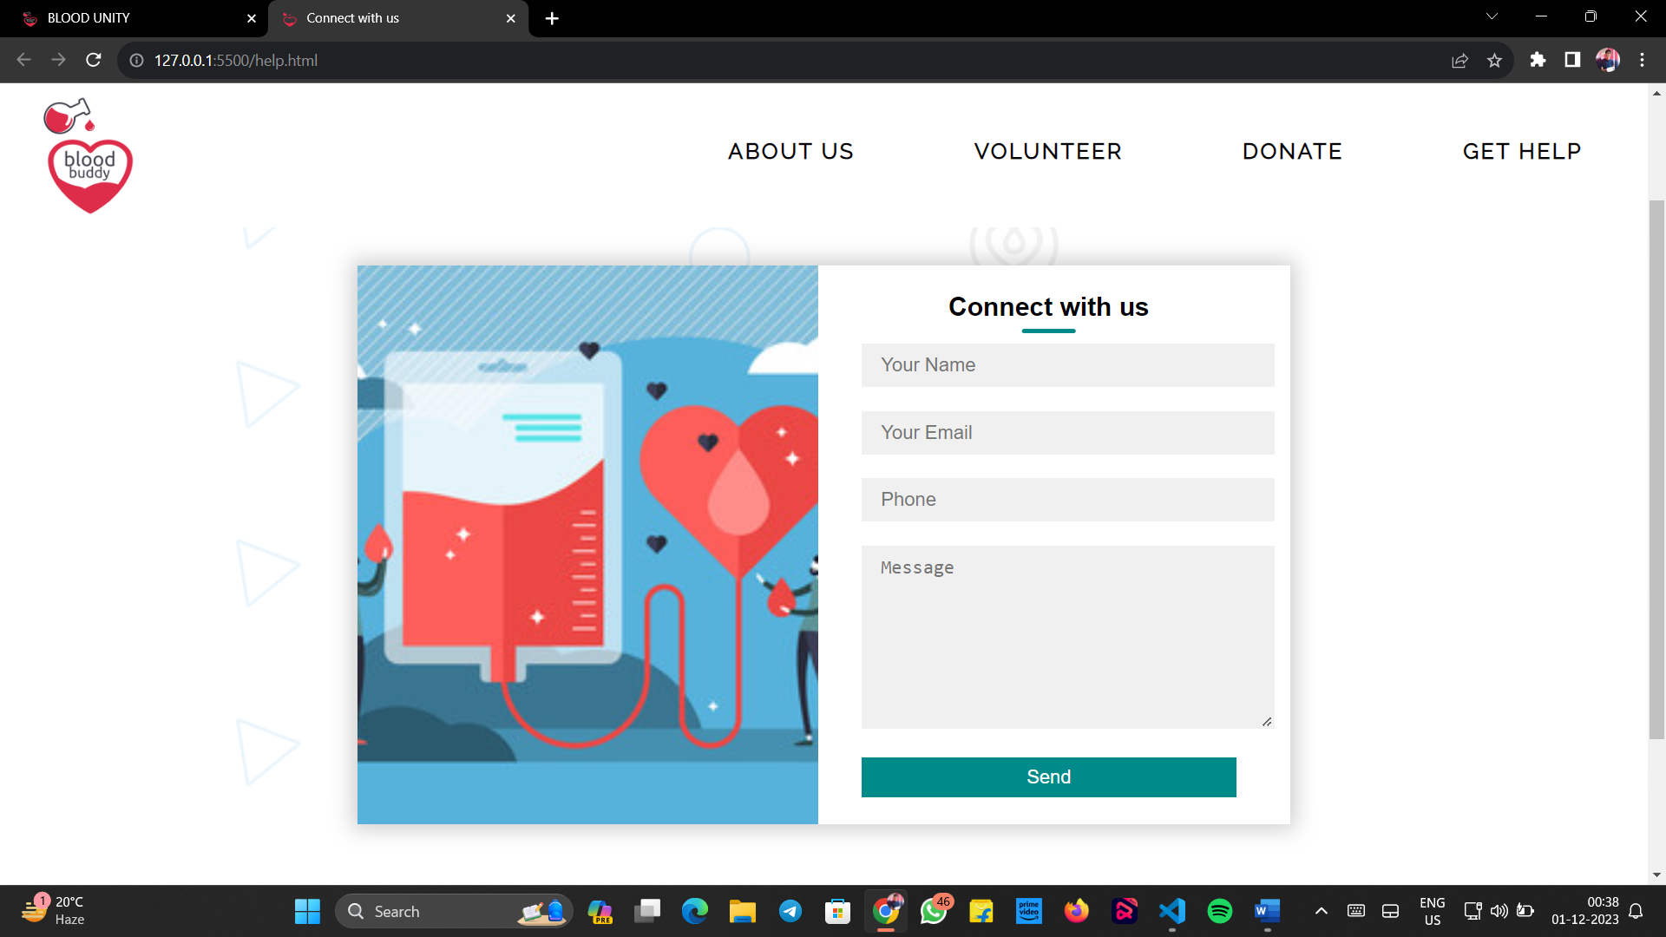

Donate Section :

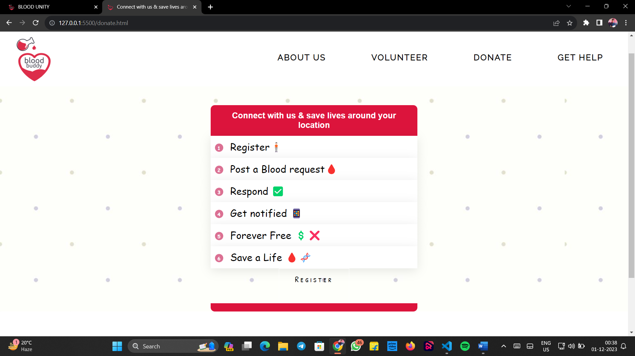

CHAPTER-4

Testing
Testing:-
Testing is a critical element of software quality assurance and represents the ultimate reviews of specification, design and coding. Testing is concerned with uncovering of the system error. Testing involves the process of checking the system thoroughly and making shore that no unwanted result it shows. So that user can access it properly and with any error.

Objective of Testing are:-
Testing is done with intent of finding an error.
A good test case is one that has high probability of finding an uncovered error.
Testing is done in order to check the various control flow of system.
Testing makes the system to work all its features properly without showing any unexpected result.

Input
Output

Input
Output

Testing Data Set:-

All the data sets are tested thoroughly and this helps in getting rid of all the errors and exception will be generated due to the lack of the data requested by the user in the database.

Our project needs no special type of testing for the data set. Because in our project the user will get all the information from the database in a predefined format set by the system developer. No other special information will be providing to the user. This makes our project simple in testing phase.

Results/ Set:-

Tester’s will find the bugs during testing and edit the bugs related information on the data base and last they will send a message( which contain developer email address and Bug Id) to the developer with in the intranet. Developer will provide the solution regarding bugs and edit the solution in the data base, which we can use in future for removing bugs from our developing application.

Administrator will perform following task: Edit / Delete / modify the information of tester and developer which will work on web application. As our system will produce the car information in a strict format which needs no special type of testing? And this our project very simple in testing phase.

CHAPTER-5
Implementation

Installation Requirement:-

Implementation means converting a new or revised system design into an operational one. Implementation is the stage of the project when theoretical design is turned into a working system. This means that the new design is implemented to establish a working system design. This stage should be handled carefully to achieve a new successfully running system giving the user confidence that the new system will work efficiently and as per the requirements.

For understanding any project some basic requirement should be fulfilled. For example, this project is build around the client server architecture. So the reader should be clear with the architecture. Also the project is developed in HTML, CSS, JS , so the reader needs to have knowledge to them also. So the reader has to be familiar with it also. Apart from the technology there are some specific terms used in the context of the project. So the meaning of all the terms should be clear, before diving into the intricacies of the project. Nevertheless, we are providing a brief overview of the technology that we have used and also we are providing the illustrated meaning of the terms that we have used, so that reader can have the basic understanding about our project at the first look.

CHAPTER-6
Conclusion & Discussion

Conclusion:

In conclusion, the "Blood Unity" project holds significant promise as a comprehensive initiative to enhance blood donation practices, community engagement, and healthcare outcomes. The preliminary investigation has provided valuable insights into the current state of blood donation, stakeholder perspectives, and potential challenges and opportunities. The identified needs and goals underscore the critical importance of fostering a sense of unity and responsibility within communities to ensure a stable and sufficient blood supply.

The project's objectives, including awareness campaigns, mobile blood donation units, and the development of online platforms, are strategically aligned to address the identified needs. By focusing on these key components, "Blood Unity" aims to create a sustainable and impactful solution that transcends geographical boundaries and leverages technology for the greater good.

The feasibility analysis has highlighted economic, technical, and operational considerations, laying the groundwork for informed decision-making in the subsequent phases of the project. The engagement of stakeholders, from healthcare institutions to community members, is vital for the success of "Blood Unity," and the preliminary investigation has provided a foundation for collaborative efforts.

Discussion:

The findings from the preliminary investigation underscore the complex interplay of factors influencing blood donation practices. The low awareness levels and potential logistical challenges present hurdles that the project must address strategically. Stakeholder interviews revealed diverse perspectives, emphasizing the need for a nuanced approach that considers the unique characteristics of different communities.

The integration of technology, through the development of online platforms and mobile units, emerges as a key strength of the project. However, careful attention must be given to ensure inclusivity and accessibility, especially in areas with limited technological infrastructure. The project team should remain vigilant in addressing potential risks identified during the feasibility analysis, such as economic fluctuations and regulatory considerations.

The "Blood Unity" project aligns with global health priorities, contributing to the overarching goal of ensuring a reliable and safe blood supply. Successful implementation hinges on effective communication strategies, robust community engagement, and continuous evaluation and adaptation to evolving needs.

As the project moves forward, ongoing collaboration with healthcare institutions, community leaders, and technology experts will be essential. Learning from similar initiatives and incorporating feedback from stakeholders will contribute to the project's adaptability and long-term success.

In conclusion, "Blood Unity" has the potential to make a substantial impact on blood donation practices, fostering a culture of unity and saving lives through collective action. The insights gained from this preliminary investigation lay a solid foundation for the next phases of the project, marking the beginning of a transformative journey toward a healthier and more connected society.

CHAPTER-7

Bibliography & References

Reference Sites:-

W3Schools:
Description: W3Schools is an online learning platform for web development, offering tutorials, references, and examples on various web technologies such as HTML, CSS, JavaScript, and more.
Strengths: Known for its simplicity and beginner-friendly approach, W3Schools provides hands-on examples and interactive coding exercises, making it accessible for learners of all levels.

MDN (Mozilla Developer Network):Description:
MDN is a comprehensive resource provided by Mozilla, offering documentation, guides, and references for web technologies, including HTML, CSS, JavaScript, and web APIs.
Strengths: MDN is highly regarded for its accuracy and depth of information. It serves as a reliable reference for both beginners and experienced developers, providing detailed insights into web standards and best practices.

